|  |  |  |
| --- | --- | --- |
| **NotificationController** | | |
| **Physical address** | admin/application/controllers | |
| **Base class** |  | |
| **Attributes** | | |
| **Name** | **Type** | **Description** |
| Pusher | object | Pusher variable to send notification |
|  |  | |
| **Operations** | | |
| index() | | |
| **Return Type** | void | |
| **Parameters** | N/A | |
| sentNotification() | | |
| **Return Type** | void | |
| **Parameters** | N/A | |
|  |  | |
|  |  | |
|  |  | |

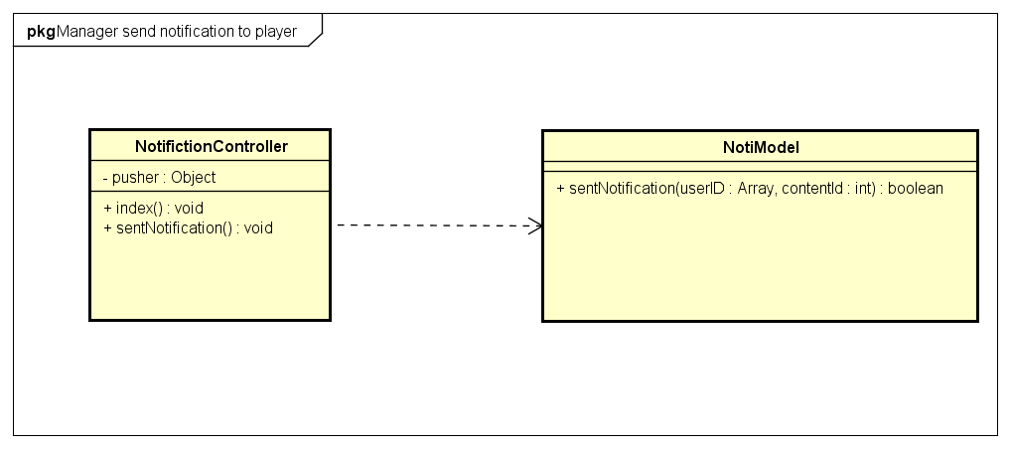

|  |  |  |  |
| --- | --- | --- | --- |
| **NotiModel** | | | |
| **Physical address** | admin/application/models | | |
| **Base class** |  | | |
| **Attributes** | | | |
| N/A | | | |
| **Operations** | | | |
| sentNotification() | | | |
| **Return type** | boolean | | |
| **Parameters** | **Name** | **Type** | **Description** |
|  | **userId** | **Array** | **User id list to sent notification** |
|  | **contentId** | **Int** | **Notification id** |